**Design Patterns – Ex1 Diagrams & Features – Ron Gissin & Itamar Romano**

**IDs: 313544298, 205389711**

**Class Diagram**

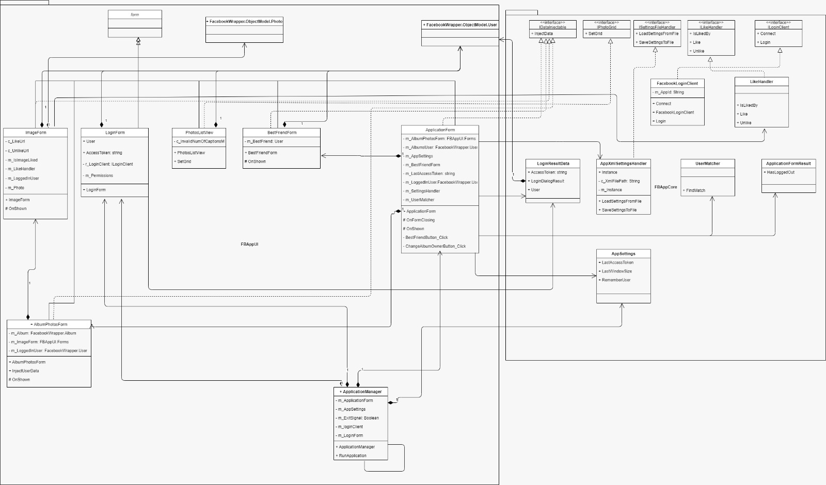

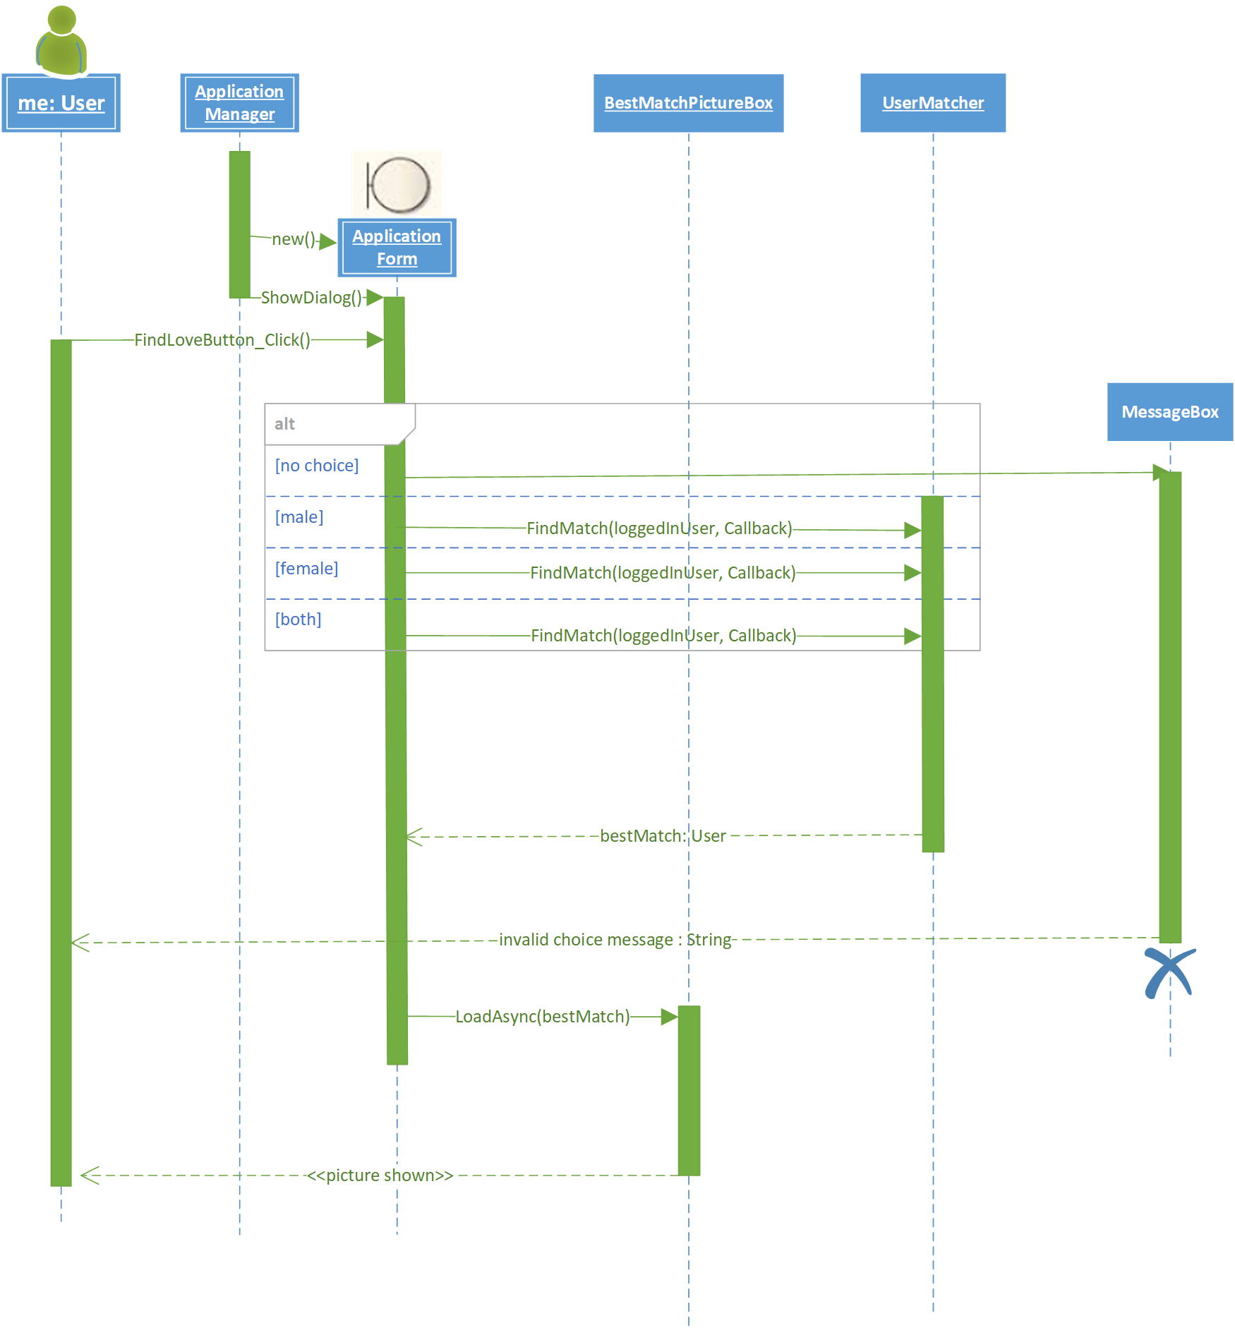**Sequence Diagram #1**

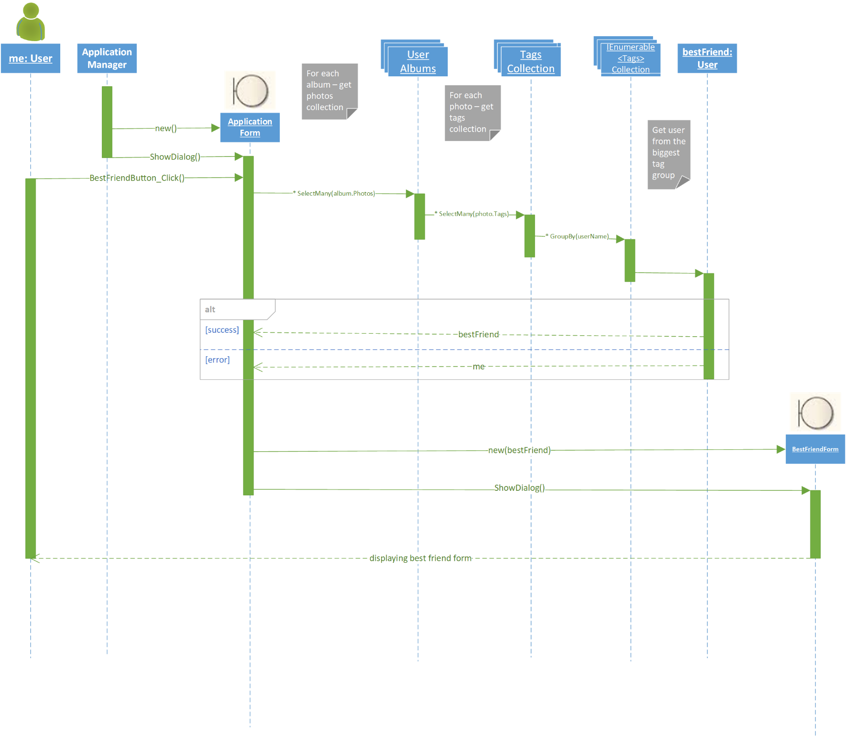**Sequence Diagram #2**

**Use Case Diagram**

**Special Features Implemented in the**

**Application**

1. **“Find your true love”** – We introduced two checkboxes that enable choosing Male, Female (multi choice).

When pressing the ‘Find Out’ button, the user’s photos are scanned to find which friend gave the user the most likes overall. The result is filtered by the users checkbox choice (gender preference).

This feature is found on the ApplicationForm UI, and its logic is implemented in the ApplicationForm code in a Click event handler, and uses the UserMatcher type to execute the match finding.

1. **“Find your best friend”** – We introduced a ‘Show me’ button. When clicked, a new form is opened revealing the user’s best friend. The best friend calculation is done by finding the friend which was tagged the most in the users overall photos.

The feature is found as well on the ApplicationForm UI, and the logic is implemented in the ApplicationForm code inside a Click event handler.

1. **“Most liked photo”** – We introduced a PictureBox which shows the most liked photo of the chosen user.

This PictureBox gets populated with the most liked photo on the ApplicationForm startup/load automatically.

The feature can be found as well on the ApplicationForm UI, and implemented in the ApplicationForm code file.